NAME: Navarro, Rod Geryk C.

COURSE/SECTION: CPE160P/A1

Assignment:

1. Using LTSpice, show the transient analysis of the following circuit.

You can download LTSpice here <https://www.analog.com/en/design-center/design-tools-and-calculators/ltspice-simulator.html> for free.

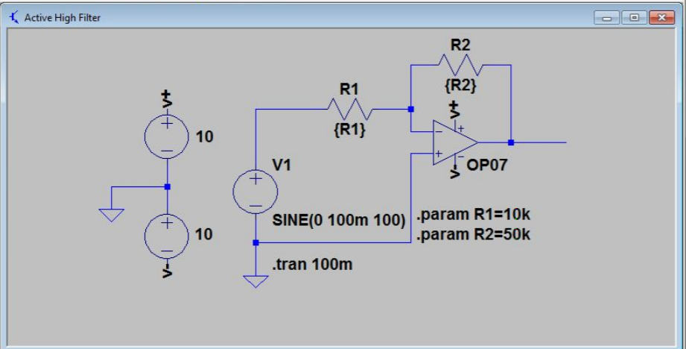

Watch the video, follow the tutorial, screenshot your created schematic and all the simulated output (place all your answers on the space provided below after all the instructions). Then upload it to the BB.

Kindly submit the **HYPERLINK** of your Course Work 1 Solution to the provided link.

1. Please follow the instructions and it is for your strict compliance.

2. Provide Solutions to Answers.

3. Upload your CourseWork1 solution to your main folder (create a subfolder COURSEWORK1)in your respective one drive accounts.

4. Copy and paste the hyperlink or share the hyperlink through a MS Word file.

5. The filename format for MS Word file is **SurnameFirstname_COURSESEC_Activity1Solution.docx.**

Example: **ManlisesCyrel_CPE160P_E01_CourseWork1Solution**

1. <https://www.youtube.com/watch?v=yQur5HqCo_4&feature=youtu.be>
2. <https://www.youtube.com/watch?v=W8dQGPCW5cM&feature=youtu.be>

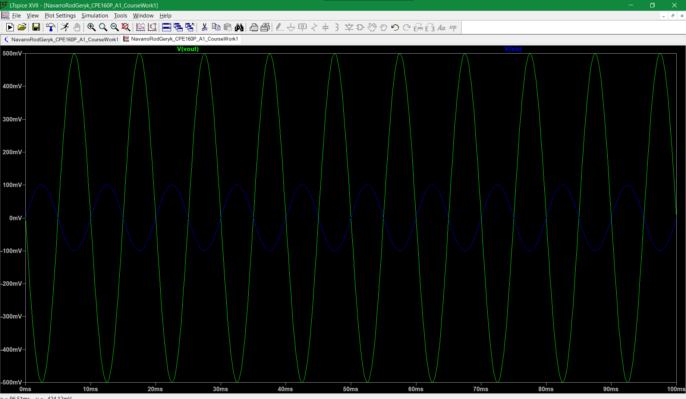

**Image 1:** The trace graph of the Vout and Vin of the given circuit. The Blue wave is the Vin and the Green wave is the Vout.

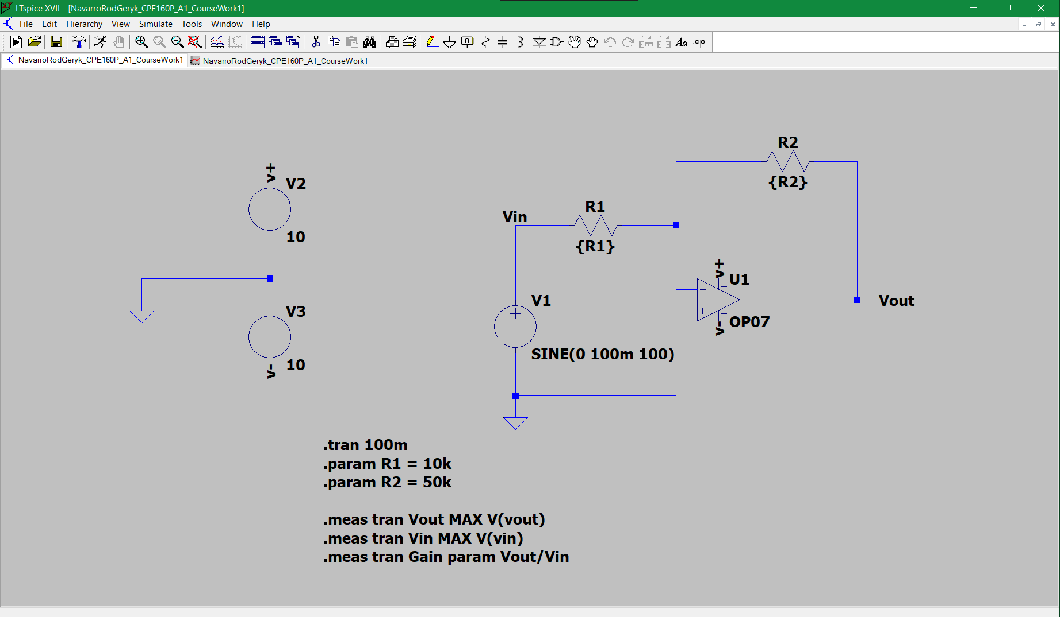

**Image 2:**  Shows the simulated circuit with the parameters and solution for the voltage gain.

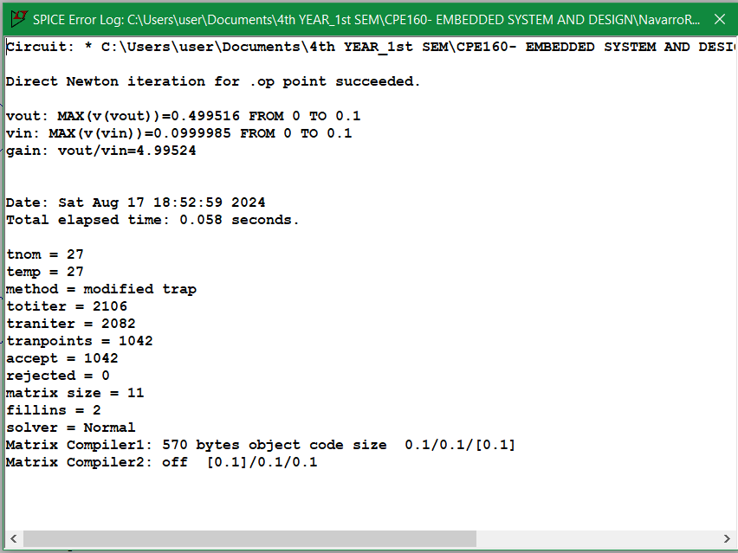

**Image 3:** Shows all the values measured using the .meas, which includes the Vout, Vin, and voltage gain of the given circuit.

[CPE160P_A1_RGCNAVARRO](https://mymailmapuaedu-my.sharepoint.com/:f:/g/personal/rgcnavarro_mymail_mapua_edu_ph/EmppapQGIH1OuteF-V0u58wBF_dGROQba2V5tSY62kylBQ?e=y2dQWn)